**Analyzing NOAA Storm Damage Data**

Project Proposal

Matthew Tuttle  
 CSPB  
 University of Colorado Boulder CO USA  
 matu8468@colorado.edu

Lex Bukowski  
 CSPB  
 University of Colorado Boulder CO USA  
Alexi.Bukowski@colorado.edu

**ABSTRACT**

Severe weather events have a profound impact on society and the world. Storms can destroy infrastructure and property, shut down critical systems, and endanger human lives. The National Oceanic and Atmospheric Administration (NOAA) has tracked and documented severe weather events, the damage they cause, and the number of fatalities dating back to 1950. The following project proposal outlines a data mining and analysis exercise that endeavors to answer interesting questions about the NOAA Storm Event data.

The end goal of the project is to enhance our understanding of severe storms and the damage they cause to humans and property by looking at any possible correlations that may exist in the data. The proposed project will utilize data mining techniques to uncover value in the massive amount of data that the NOAA has collected over the past 70+ years. By implementing methods such as clustering, classification, and regression, this project will provide storm forecasters, community leaders and decision makers, and everyday citizens with key information about storm events and the damage and destruction that they may bring.

**CCS CONCEPTS**

• Mathematics of computing • Mathematics of computing ~ Probability and statistics • Mathematics of computing ~ Mathematical analysis • Mathematics of computing ~ Probability and statistics ~ Probabilistic representations • Mathematics of computing ~ Probability and statistics~ Probabilistic inference problems • Mathematics of computing ~ Probability and statistics ~ Probabilistic algorithms

**KEYWORDS**

Storm events, Storm damage, Property damage, Natural disaster, Weather events, Severe weather, Weather damage, Weather fatalities

**ACM Reference format:**

Lex Bukowski and Matthew Tuttle. 2023. Analyzing NOAA Storm Damage Data. *4 pages.*

1**Problem Statement and Motivation**

Many interesting questions about the severe weather events and storm damage data exist such as: What type of weather is the most dangerous to people and property? Is the magnitude of property damage indicative of higher risk of injury to people? Are certain locations prone to multiple types of dangerous weather events? Do longer weather events lead to more property damage? Have severe weather events increased over time?

Answering these questions will allow for a better understanding of the risk of severe weather events and allow for better prediction of the outcomes of severe weather events. Armed with this information, future weather events, even if more severe, can cause less damage to people and property, potentially saving lives and preventing huge expenditures.

The questions surrounding the occurrence of events over time will give insight into possible other causation factors as well as other interesting questions to be explored. Most notably if severe weather events are increasing over time, does global warming and climate change play a role in the occurrence and severity of these events.

2 **Literature Survey**

In conducting background research on this project, topic, and data set, two previous published papers were discovered. They are discussed below.

2.1**Text Mining of NOAA Data**

Emma Louise McDaniel analyzed the NOAA dataset previously by implementing a text mining algorithm to uncover the true nature and severity of a severe weather event. The logic supporting this study was that although important for insurance adjustments, monetary cost is not always the most prevalent or usable metric to determine the scale and severity of a storm event. McDaniel summarizes this argument with the following quote from her abstract “The monetary impact of a disaster is not conducive for disaster preparedness planners to build community resilience.”[1]

McDaniel’s work was subsequently to text mine the narratives given about the severe weather events included in the database. This work proved to be difficult as the natural language was very unstructured. However, that doesn’t make the information contained in the narrative any less important. McDaniel’s work was a first step toward extracting and classifying key words and terms out of the storm event narratives to determine a relationship between those key terms and a storm's true (not just monetary) effect. Below is a citation of McDaniel’s work, which is also included in the references section at the end of this proposal.

[SAC '23: Proceedings of the 38th ACM/SIGAPP Symposium on Applied Computing](https://dl.acm.org/doi/proceedings/10.1145/3555776). March 2023 Pages 653 – 656 <https://doi.org/10.1145/3555776.3577211>

2.2**Comments on Reliability of NOAA’s Storm Events Database**

Renato P Dos Santos analyzed the reliability, completeness, and high-level validity of the dataset. Dos Santos understood the limitations of validating every input into the database due to the size of the dataset, but took a high-level approach to do a quick analysis on completeness and consistency of the data.

Dos Santos concluded that although there have been standardization efforts on the part of the NOAA to make the database more usable and effective, there are many non-standard event types in the database. Along with those inconsistencies, Dos Santos added that many damage reports are missing and many damage values are incorrect.

Below is a reference to Renato P Dos Santos work, which is also included in the references section at the end of this proposal.

P dos Santos, Renato, Some Comments on the Reliability of NOAA's Storm Events Database (June 22, 2016). Available at SSRN: <https://ssrn.com/abstract=2799273> or [http://dx.doi.org/10.2139/ssrn.2799273](https://dx.doi.org/10.2139/ssrn.2799273)

3**Data Set**

The data set that this project will work with is the “NOAA Storm Events Database.” This database is free and open to the public and can be found at the following URL: <https://www.ncdc.noaa.gov/stormevents/ftp.jsp>.

Summarized but detailed information about the contents of the database can be found at the same URL. The database includes columns that contain information on the details, locations, and fatalities of each storm event, linked by the primary key of the event ID number.

The Details table includes information such as the timing, general location, event type, reported injuries, reported deaths, crop damage, property damage, and the storm narrative (more information is housed in this table, these are just the most relevant fields for this proposal). The Storm Data Location table includes much more detailed location information and the Storm Data Fatality table does the same for the reported fatalities.

It is worth noting that the database has entries from three different phases. From 1950-1954, the database contains only information on tornado damage. From 1955-1995, damage from thunderstorms, wind, and hail was also included. Finally, from 1996 onward, data was collected for a total of 48 event codes. Care will have to be taken to constrain analysis of events over time to the proper time periods based on the available data.

Reporting standards for the data have changed drastically in the lifespan of the data, with major changes occurring at each of the time intervals mentioned above. For a two-year span between 1993 and 1995, events were recorded in unformatted text files. Only tornado, thunderstorm, wind, and hail events were extracted from these files (the same events recorded from 1955 through 1992). The first attempt at meaningful standardization was taken in 1996 with the standardization of event types.

As mentioned in the analysis of previous work involving this data set, that standardization still has significant issues, especially do to the important nature of the free text and description fields for classifying these events. Due to these facts, significant work will be done to clean this data set for analysis, and most analysis will be completed on the events post-1996. It is important to note that analysis done on the entire data set will be skewed toward the tornado, wind, thunderstorm, and hail events that have a broader range and timeframe of data collection.

4**Proposed Work**

4.1**Preprocessing**

There is a significant amount of preprocessing that will need to be completed on this data set. The heart of the dataset are the fields EVENT_TYPE, PROPERTY_DAMAGE, CROP_DAMAGE, INJURIES_DIRECT, and INJURIES_INDIRECT. All of these fields have some significant issues that will need to be addressed before the data can be analyzed.

The EVENT_TYPE field officially has 48 possible event types, but the database includes a total of 70 different labels. Many of these non-standard labels are combinations of existing labels. It will need to be determined if the non-standard labels need to be recategorized, and how combination labels should be dealt with.

The PROPERTY_DAMAGE and CROP_DAMAGE fields represent storm damage in dollar value. However, these are not numeric fields but instead are stored as strings with a magnitude signifier as the last character. For example, damage of $25,000 might be stored as ‘25.0K’ with K signifying a magnitude of 1,000. There are a number of non-standard signifiers (e.g. ‘?’) which will likely result in the data rows being removed. Additionally, there are a significant number of entries in the data set that have empty values for both damage types. Given that inclusion in the data set is predicated on damage this is likely an error and will need to be resolved.

Finally, the INJURIES_DIRECT and INJURIES_INDIRECT fields appear to be much less problematic as they are integer valued. However, only 0.7% of all data entries caused either a direct or indirect injury. Additionally, over half the total injuries in the database were caused by 5 events. With such sparse/concentrated data, conclusions will have to be drawn very carefully.

4.2**Data Integration**

Population and infrastructure density are a significant variable in storm damage that is not currently captured in the database. The database does provide standardized region labels for storm locations as well as the latitude and longitude of storms. If needed, these fields can be used to tie in an outside data source to provide per capita normalization of damage and injuries.

4.3**Classification and Analysis**

After completing the data preprocessing and any required or added data integration, classification and analysis will be performed on the cleaned and complete data set to determine possible correlations that exist in the dataset.

4.4**Conclusion**

The goal of this project is to make informed conclusions about correlations between severe weather events occurrence, damage, and death toll by analyzing the other factors provided in the data set. The last step of the project will be drawing these conclusions from the data processing, integration, and classification steps. Care will be taken to not apply unnecessary causation, but simply show determined correlations.

A possible conclusion for this project, as noted from previous works done above, is that the data set, although encompassing over 70 years of information, does not contain enough structured information to determine interesting correlations with a strong support basis.

5**Evaluation Methods**

The possible correlations between attributes of the data set and/or if the occurrence of attributes is increasing (or decreasing) with time will be evaluated using various methods. Graphically, information from scatter plots and box plots will be used along with more numerical methods of R-squared and Pearson correlation coefficients.

Due to previously referenced work completed by P dos Santos, evaluation of the data set as a whole needs to be addressed as well. The data set will be analyzed for completeness and consistency while evaluating correlations. Confidence intervals and residual analysis will be utilized to help determine if correlations appear poor due to poor data quality or accurate data analysis.

6**Tools**

A number of tools will be used for this analysis. An exploratory analysis of the data will be performed with python using pandas and numpy paired with matlibplot and seaborn for data visualization.

Pandas data frame library will be used to create a data frame by importing the CSV files containing the years of storm event data. Once created, the data frame will allow for data manipulation, cleaning, and visualization using other tools.

Seaborn’s plotting abilities will be used to help gain an understanding of possible trends in the data set by plotting each event type vs the direct injury count. The seaborn library will allow for the generation of a scatter plot for a visualization of the injury count density for each event type and a box plot to determine the range of meaningful data points for each event type. This initial visualization of the data will provide initial insight into the proposed questions and give a starting point for more analysis.

Classification and regression analyses will be done in python using a combination of the sklearn and statsmodel libraries.

Documentation for all described libraries is readily available online.

6.1**Exploratory Tools**

Pandas and Numpy are libraries built on top of the Python language that will help simplify, clean, and analyze the dataset. Both tools will be used extensively with the goal of standardizing and gaining a high level understanding of the data. This will allow for effective classification and regression analysis, as opposed to choosing data traits randomly. Matlibplot and seaborn will help visualize the information gained during this data scrubbing process and will also provide visuals for final presentation of the data.

6.2**Classification and Regression Tools**

The sklearn and statsmodel libraries are tools built on top of python that will allow for effective classification and regression on data traits that were identified as important and relevant from the cleaning phase.

7**Milestones**

7.1**Milestones Completed**

7.1.1 Data Pre-processing

As mentioned numerous times, due to the nature of the data set, the data pre-processing was a key step in this project to ensure useful information is being used in classifications and trend analysis. This step has been completed by using pattern analysis on the file structure to create a pandas data frame. Using the data frame, data issues and discrepancies could be determined by using the pandas library to analyze columns, unique data counts, and missing data. This milestone was completed the week of November 13th.

7.1.2 Data Integration

Data integration of the multiple data sets included in the storm events database has been completed and a pandas data frame has been constructed with the data that will be mined. This was completed the week of November 27th. This step proved to be more difficult than expected due to the poor data standardization of each data set. The lack of standardization made integrating information across the data sets a challenge, and due to the changed nature of the data after the cleaning and pre-processing, not all data was able to be integrated into the pandas data frame.

7.2**Milestones To-do**

7.2.1 Data Classification

Data classification and analysis will be completed the week of December 4th. Now that a cleaned pandas data frame exists, the classification of similar storm events into a smaller set of more meaningful groups can be completed. From there, the information relating to event frequency (count), severity (injury count and damage cost), and location can be mined to determine if any correlations exist.

As mentioned in the evaluation methods, R-squared coefficients and Pearson coefficients will be used to evaluate correlations, while also using a supervised approach to ensure that poor data quality is not providing statistically relevant data due to the fact of a lack of completeness or standardization of the data set.

7.2.2

Conclusions, final reports, and presentations will be completed the week of December 11th.

8**Results So Far**

Seaborn plots of the pre-processed and cleaned data have provided insight into what event types have caused the most damage and the highest injury count. Below are a pair of box plots of the number of injuries directly caused by each event type.

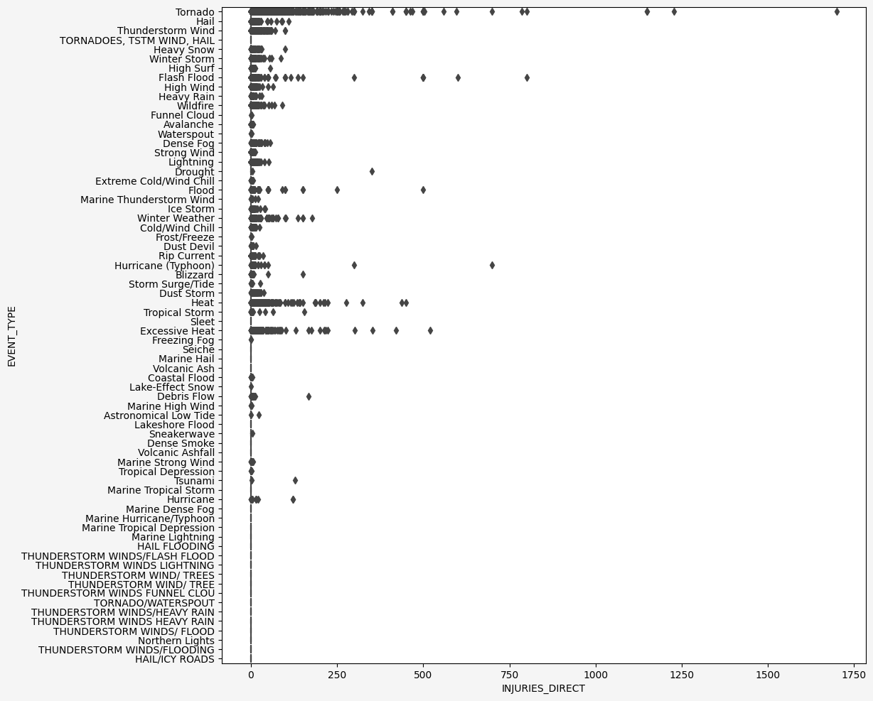

Figure : Box Plot of Injuries by Event Type with Outliers Included

Figure : Box Plot of Injuries by Event Type with Outliers Excluded

As can be seen comparing the two plots, the median injuring event only causes a handful of injuries for most event types. On the other hand, single outlier events have caused hundreds or thousands of injuries. A larger view of all figures can be found in Appendix A.

A similar pattern also holds for monetary damages from weather events, with outlier events causing orders of magnitude more damage than the median event of each type.

Figure : Box Plot of Property Damage by Event Type with Outliers Included

Figure : Box Plot of Property Damage by Event Type with Outliers Removed

To illustrate how skewed the amount of damage caused by extreme events is, Figure 5 shows the share of total property damage by year caused by different quantiles of events by damage caused. In most years, the 99th percentile events cause almost 95% of the total property damage, and the 95th+ percentile events are responsible for 98-99% of all property damage in a year. This just emphasizes that this database is explicitly a collection of outlier events (weather events that cause damage or injuries in the first place) that is dominated by the biggest outliers.

Figure : Property Damage Share by Event Quantile

**ACKNOWLEDGMENTS**

Acknowledgements should be made to both Emma Louise McDaniel and Renato P Dos Santos whose previous work with the data was taken into consideration when determining the proposed work and evaluation methods included in this proposal.

Professor Kristy Peterson (University of Colorado Department of Computer Science) and the University of Colorado CSPB 4502 Fall 2023 course participants also provided feedback, critiques, and suggestions to this proposal idea and draft.

**REFERENCES**

[1][SAC '23: Proceedings of the 38th ACM/SIGAPP Symposium on Applied Computing](https://dl.acm.org/doi/proceedings/10.1145/3555776). March 2023 Pages 653 – 656 <https://doi.org/10.1145/3555776.3577211>

[2]P dos Santos, Renato, Some Comments on the Reliability of NOAA's Storm Events Database (June 22, 2016). Available at SSRN: <https://ssrn.com/abstract=2799273> or [http://dx.doi.org/10.2139/ssrn.2799273](https://dx.doi.org/10.2139/ssrn.2799273)

**Appendix A**



Figure 1: Box Plot of the direct injury count for each event type in the data set with outliers included.

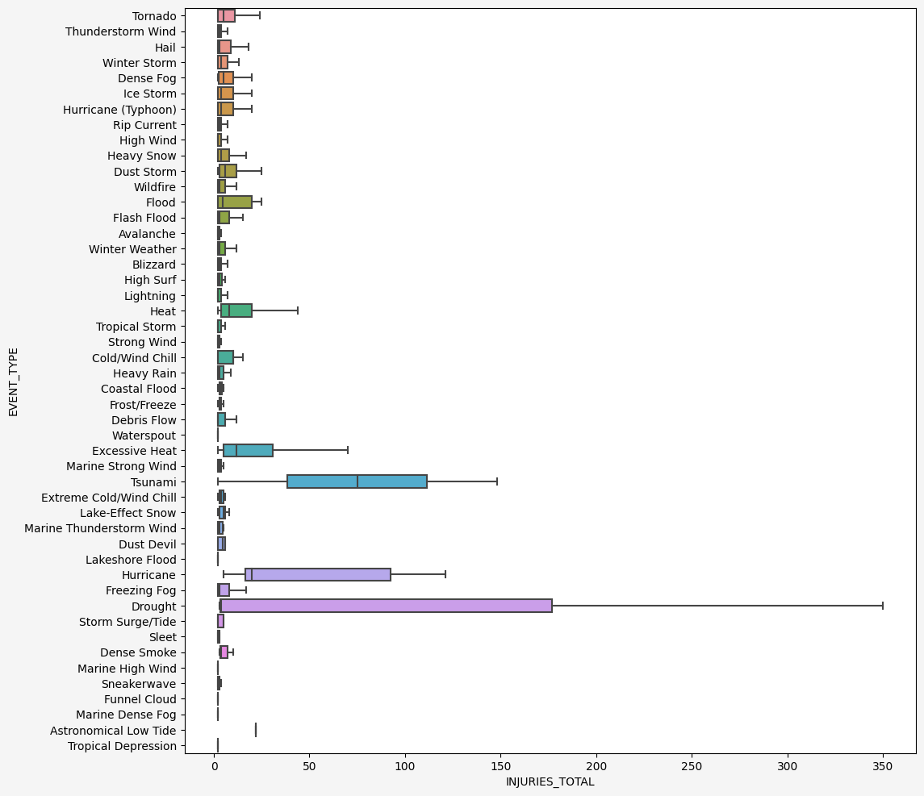

Figure 2: Box Plot of the direct injury count for each event type in the data set with outliers excluded.

Figure 3: Box Plot of Property Damage in dollars for each event type in the data set with outliers included.

Figure 4: Box Plot of Property Damage in dollars for each event type in the data set with outliers excluded.

Figure 5: Plot of share of total Property Damage in dollars by year by quantile